Comfort

Convenience

*Where it can be used*

**Titles of the quote**

“” Quote

**Title of Publishment**

Authors

**Quotes**

*Can be used in intro or the objectives*

**Quote on shoppinglist**

“Shopping is one of the most frequently occuring tasks in our daily lives…small tasks that are carried out repeatedly”

**The Hybrid Shopping List: Bridging the Gap between Physical and Digital Shopping Lists.**

Felix Heinrichs, Daniel Schreiber, Johannes Schoning

From this we can see that although the age old problem of shopping lists and stock handling isn’t the most complex, the fact that it is done almost every day, which accumulates numerous wasted hours where a more efficient form of application could help.

*Introduction when talking about smart fridges*

**Quote on intelligent refigerators**

“intelligent refrigerator for food management is developed, food records the within the refrigerator is achieved. These data will be automatically uploaded to the production of intelligent refrigerator cloud data service platform, easy to be viewed by the user. And according to the food inside the refrigerator it can provide recipes.”

**Intelligent Refrigerator Based on Internet of Things**

**Shouming Qiao,** **Hongzhen Zhu, Lijuan Zheng, Jianrui Ding**

*Intro/ background*

**Quote on an encompassing smart home system to work towards**

**“**Both Research and Industry have focused on the development of the Smart Home Environment. Developing Smart Appliances is directly proportional to Developing Smart Home environment. It is a critical factor in the realization of the smart home environment.**”**

**Intelligent refrigerator using ARTIFICIAL INTELLIGENCE**

**Shweta A.S**

This smart home environment would be a nirvana for smart home technologies, as it reaches a point where all things that can be automated, are, and it can allow the user free control of the house, and its inner functionalities such as heating.

*Intro/background*

**Quote on importance of smart home technology in kitchen**

“Kitchen is one of the most important places for a Smart home as it consists of many Appliances which provide better services to the household.”

**Intelligent refrigerator using ARTIFICIAL INTELLIGENCE**

**Shweta A.S**

For a smart home environment to be fully complete the integration of the kitchen must be used alongside other appliances, this is where stokk comes in as, it not only would sort the issues within the kitchen of recipe handling and stock control, but help with the kitchen functionality outside of the kitchen, such as shopping and needing a shopping list.

*background*

Quote on results of using sht

“Results showed that approximately a year after installation, many of the initial expectations of the benefits were met”

**Smart home technology—comparing householder expectations at the point of installation with experiences 1 year later**

Luis Oliveira, Val Mitchell & Andrew May

Perceived benefits of implementing smart home technology were reached and, in most cases, made the job it covered more comfortable and convenient

“When expectations were not met, this was usually due to the effort required to set up and control systems, rather than the lack of functionality.”

**Smart home technology—comparing householder expectations at the point of installation with experiences 1 year later**

Luis Oliveira, Val Mitchell & Andrew May

A system may eventually be more useful when all the data needed is collected, but for a new user the level of effort to set up the application must be simple and not complex, requiring the user to not constantly input data for the application to function.

So, the application must have sufficient automation to avoid constant user input, but allow the user to input data where necessary.

*Background*

**Share of households with a computing device in the UK in 2020, by device type**

Published by [Thomas Alsop](https://www-statista-com.plymouth.idm.oclc.org/aboutus/our-research-commitment/2474/thomas--alsop), Jul 23, 2020

 Of the 2,675 households with a computing device in the United Kingdom (UK), 57 percent had a laptop in their household in 2020. Whereas 24 percent owned a personal computer.

**Does your household have a desktop PC, laptop, netbook or tablet computer?**

“The global smart home market revenue was forecast to reach a value of more than 141 billion U.S. dollars by 2023.”

[H. Tankovska](https://www-statista-com.plymouth.idm.oclc.org/aboutus/our-research-commitment/2083/h-tankovska), Sep 30, 2020

Smart home - Statistics & Facts

**Number of Smart Homes forecast worldwide until 2025**

Published by [Dr. Jeremiah Lasquety-Reyes](https://www-statista-com.plymouth.idm.oclc.org/aboutus/our-research-commitment/2621/dr-jeremiah-lasquety-reyes), Nov 11, 2020

 This statistic presents a forecast of the number of Smart Homes in the Smart Home market worldwide until the year 2025. According to the Digital Market Outlook.

**Number of Smart Homes forecast worldwide from 2017 to 2025***(in millions)*

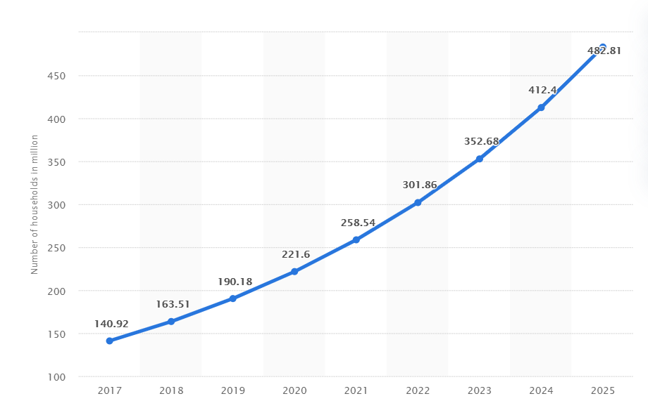

Projected smart home forecast 2017-2025

**Smart Home revenue forecast worldwide until 2025**

Published by [Dr. Jeremiah Lasquety-Reyes](https://www-statista-com.plymouth.idm.oclc.org/aboutus/our-research-commitment/2621/dr-jeremiah-lasquety-reyes), Nov 11, 2020

 This statistic presents a forecast of the revenue in the Smart Home market worldwide until the year 2025.

**Smart Home - revenue forecast worldwide from 2017 to 2025***(in million U.S. dollars)*

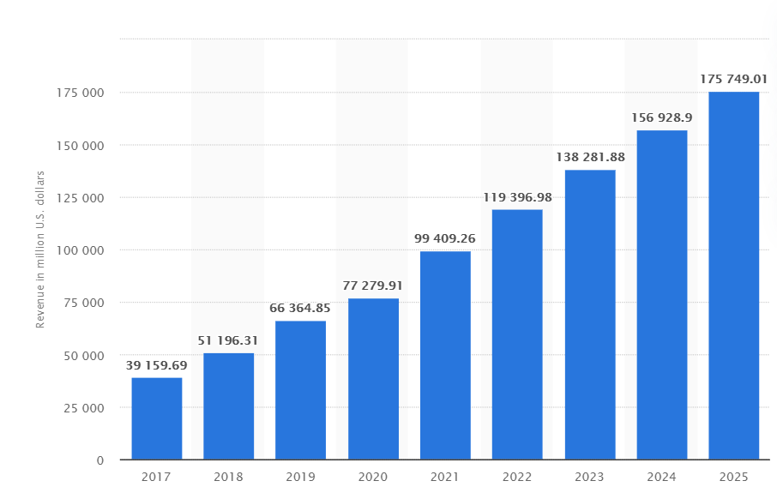

As seen by the graphs smart homes are projected to rise, and at a pretty steady rate, predicted to have 482 million households using some form of smart home technology by 2025, which could bring revenue around 175 billion dollars in 2025. This market if approached in the right way, by creating an application that doesn’t have many parallels to other systems that already exist, could bring major income to the developers.

*For Design sections*

HCI Quotes

” Human– Computer Interaction (HCI) is the study of the way in which computer technology influences human work and activities.” (Dix A., Human-Computer Interaction, Encyclopedia of Database Systems. 2009).

“Accuracy of recall was higher at longer retention intervals, in contrast to the usual fall of accuracy with time which is seen when retention is measured over a period of minutes or longer.” (Crawford, J., Hunt, E., & Peak, G., Inverse forgetting in short-term memory. Journal of Experimental Psychology, 1966).

The use of a UI which can be accessed on both Desktop and mobile browser, which has the same flow and consistency amongst different forms of users. Which means if the user uses any device either desktop mobile or tablet, the application should still look the same, meaning the user will have little issue navigating and remembering how to navigate through other devices.

*in reflection*

“They're mainly solutions in search of a problem”

Home automation is a solution in search of a problem

Galen Gruman 2014